|  |
| --- |
| **Reports** (up to ~2500 words including references, notes and captions or ~3 printed pages) present important new research results of broad significance. Reports should include an abstract, an introductory paragraph, up to four figures or tables, and about 30 references. Materials and Methods should usually be included in [supplementary materials](http://www.sciencemag.org/site/feature/contribinfo/prep/prep_online.xhtml), which should also include information needed to support the paper's conclusions. |

The Importance of Early Attitudes Towards Math and Science

Students with consistently positive attitudes toward mathematics and science were more likely to pursue careers in science and be more supportive of science while adolescents with negative attitudes toward mathematics and science were more likely to have consistently negative attitudes toward science and be less supportive of science at the end of twelfth grade, emphasizing the importance of encouraging and supporting early positive attitudes.

There are multiple goals to science education reforms such as the Next Generation Science Standards. One goal is to increase the number of qualified students who are interested in pursuing careers in science. Another goal is to increase the science and technological literacy of all students to create a more informed general public that actively engages and supports scientific innovation and discovery. Central to these multiple goals is improving all students’ attitudes towards science and mathematics (Osborne, Simon, & Collins, 2003).

There is evidence that there is a decline in student attitudes toward science (Breakwell & Beardsell, 1992; Hadden & Johnstone 1983; Harvey & Edwards 1980; Johnson 1987; Simpson & Oliver 1985; Smail and Kelly, 1984; Yager and Penick 1986) and that student attitudes shift depending on factors such as the who is teaching science and what sort of science they are teaching (Havard, 1996; Osborne & Collins, 2000; Whitfield, 1980). Despite best efforts to improve these various factors such as professional development opportunities for science teachers or curricular reform efforts, we know little about the long-term implications of these efforts on student attitudes. This study explores how enduring and persistent early student attitudes are toward mathematics and science using a nationally representative, longitudinal data from seventh through twelfth grade. In doing so, we addressed the following questions: 1) How stable are student attitudes towards mathematics and science from seventh through twelfth grade?; 2) Do females or underrepresented students change their attitudes toward mathematics and science more than males from seventh through twelfth grade?; and 3) Are attitude trajectories related to STEM career persistence, interest in science and support for science? This study identifies particular grade levels where student attitudes for particular types of students might be vulnerable to shifting and the extent to which such attitudes towards are persistent and relate to long-term outcomes.

**Survey and Analysis**

We used the Longitudinal Study of American Youth (LSAY) for this study. The LSAY was funded by the National Science Foundation in 1986 to examine the development of student achievement in middle and high school and the relationship of those patterns to career choices. There were two cohorts of students: a seventh grade cohort and a tenth grade cohort. Annual data collection continued one year beyond high school for the seventh grade cohort and four years beyond high school for the tenth grade cohort. Follow-up data collection efforts for both cohorts started in 2005 (when participants were in their mid-30’s). The students included in this particular study were from the seventh grade cohort. The cohort consists of students from 52 middle schools across the United States in 1987 (*N* = 3,116). Approximately 60 students were randomly selected from each school. The sample is predominantly White (70%) with approximately equal numbers of females (48%) and males (52%). The sample included 9% Hispanic, 11% African American, 4% Asian, and 2% Native American (5% of students did not indicate any race/ethnicity). Thirty-one percent of the students in the sample had at least one parent who completed college, while the other 69% did not. This study included data from students who completed an attitudinal questionnaire in seventh grade and math achievement tests every fall through the end of their high school years. In 2007, more than 95% of the original sample completed a questionnaire about their educational and occupational outcomes (Miller, 2010).

We analyzed the longitudinal attitudinal data in seventh grade, ninth grade and eleventh grade using latent transition analysis. Materials and methods are available as supplementary material on Science Online.

**Results and Discussion**

Four attitudinal profiles were found that varied in their affinity towards math and science. These four profiles were consistent across each grade level, though the relative size of each of the profiles differed (see legend in figure below). As depicted in the figure below, there was a consistent group of students who had positive attitude towards math and science that ranged in size between 18%-21% of the sample. There were student who didn’t like math or since (ranging from 27%-21% of the sample), and a class that was indifferent (between 24% and 29%). There were also students that had qualified positive attitudes—that is, they liked math but not science. These students were between 21%-27% of the sample.

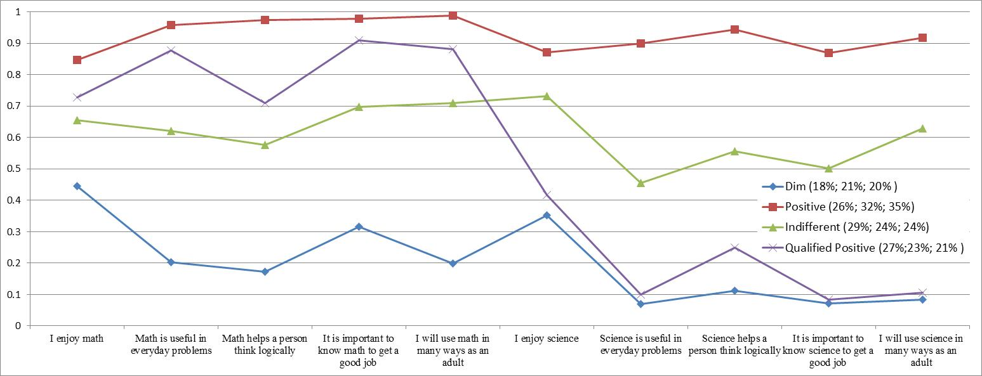

Though the relative size of the classes remained relatively stable, our results revealed that for some students, their attitudes towards math and since changed over time—some in a positive direction, some in a detrimental direction.

* Attitudes consistently related to mathematics (and science?) achievement in that students with more positive attitudes towards math and science had higher math and science test scores.
* Attitudes related to gender in grade 7 but not 10th or 12th grade.
* Attitudes not related to ethnicity in grades 7 and 12 but related in grade 10.

The stability of the four classes varied. Attitudes are enduring and persistent for 60% of the sample.

Stability of the four classes varied

* ??Attitudes are enduring and persistent for some but not all students. Might depend on where you start??
* ??Greater stability in attitudinal profiles in 10th and 12th grades; if you were in the dim class in 10th grade 62% probability of being in dim class in 12th grade. If you were in the positive class in 10th grade, 69% probability of being in positive class in 12th grade.??
* ??Less stability in attitudinal profiles in 7th grade??
* ??Students with dim attitude in 7th grade, were more likely to have a dim attitude in 10th grade (46%) and if they transitioned to another class, they were likely to transition to either the qualified positive or indifferent class rather than the positive class.??
* ??Stability matters for STEM career attainment. Students who were consistently in the positive class were more likely to pursue STEM careers compared to students who moved around from positive class to other class.??
* ??What matters is not whether or not students have a particular positive attitude in a single year but what their attitudinal profiles look like across multiple years. Those who are in the positive attitude group and negative attitude group across all three years demonstrate a resistance to change despite whatever interventions or factors might come to them. Those who are in the indifferent or qualified positive class tended to fluctuate or be more susceptible to year-to-year changes compared to students in the other two classes.??
* Take away: students attitudes can change and we have the ability to change the trajectory of students. Looking at grade 12, or any specific time point, doesn’t tell the entire story. This is promising because it shows that we have the opportunity to improve the outcome for these children if we pay attention to their attitudes and how they are developing over time.

These results highlight the importance of supporting and sustaining early interest in mathematics and science. For particular groups of students, their attitudes shifted more frequently than other groups of students. We should care about early interest given the long term consequences. It is also not a guarantee that an early positive attitude will sustain through high school. In fact, it is more likely that student’s attitudes toward science and math decline through high school and never improve after tenth grade (see for example, Aschbacher, Li, & Roth, 2010).

Possible figures

Figure: single year class membership with items

Figure: long term class membership (some pie chart alternatives.docx)

Figure: proximal outcome (achievement)

Figure: distal outcome (STEM career attainment)

References

Ajzen, I, & Fishbein, M. (1980). Understanding attitudes and predicting social behavior. Englewood Cliffs, NJ: Prentice Hall.

Breakwell, G. M., & Beardsell, S. (1992). Gender, parental and peer influences upon science

attitudes and activities. Public Understanding of Science, 1, 183–197.

Ebenezer, J. V., & Zoller, U. (1993). Grade 10 students’ perceptions of and attitudes toward

science teaching and school science. Journal of Research in Science Teaching, 30, 175–186

Hadden, R. A., & Johnstone, A. H. (1983). Secondary school pupils’ attitudes to science: the

year of erosion. European Journal of Science Education, 5, 309–318.

Harvey, T. J., & Edwards, P. (1980). Children’s expectations and realisations of science. British

Journal of Educational Psychology, 50, 74–76.

Havard, N. (1996). Student attitudes to studying A-level sciences. Public Understanding of Science, 5(4), 321–330.

Johnson, S. (1987). Gender differences in science: parallels in interest, experience and

performance. International Journal of Science Education, 9, 467–481.

Osborne, J., Simon, S., & Collins, S. (2003). Attitudes toward science: A review of the literature and its implications. International Journal of Science Education, 25(9), 1049-1079.

Simpson, R. D., & Oliver, J. S. (1985). Attitude toward science and achievement motivation

profiles of male and female science students in grades six through ten. Science Education, 69, 511–526.

Smail, B., & Kelly, A. (1984). Sex differences in science and technology among 11 year old

schoolchildren: II – affective. Research in Science & Technology Education, 2, 87–106.

Sundberg, M. D., Dini, M. L., & Li, E. (1994). Decreasing course content improves student

comprehension of science and attitudes toward science in freshman biology. Journal of

Research in Science Teaching, 31, 679–693.

Weinburgh, M. (1995). Gender differences in student attitudes toward science: A meta-analysis of the literature from 1970 to 1991. Journal of Research in Science Teaching, 32(4), 387-398.

Whitehead, J. M. (1996). Sex stereotypes, gender identity and subject choice at A level. Educational Research, 38, 147–160.

Yager, R. E., & Penick, J. E. (1986). Perception of four age groups toward science classes, teachers, and the value of science. Science and Education, 70, 355–363.